**CZ2006 Lab 1 submission**

Lab group: MACS2

Group name: AbDulBaRiwOrshipPers

Group member: Tang Yi Qwan (group leader), Deng Cheng (assistant group leader), Jaiswal Arnav, Chen Peilin, Chan Joshua Juan Yin

**Our product**

A mobile application

**Product name**

ToiLocator

**Project mission statement**

ToiLocator is a mobile app that provides a convenient way for the general public to search for the nearest public toilets from their current locations, as well as view toilet information and leave reviews of the toilets they have used.

Toilocator aims to improve the overall public toilet experience of the general Singapore population by searching the nearest public toilets from user location, displaying relevant toilet information and reviews of the toilet left by other users.

**Functional requirements**

**System functionality to be performed + Information to be processed**

1. The system must be able to display all public toilets within 1km in order of proximity from the user’s current location within 5 seconds after launching the app.
2. Upon user’s command, the system must be able to provide one recommended toilet based on proximity (nearest toilet).
3. For each displayed toilet, the system must be able to provide estimation of potential crowd.
   1. The system shall provide information of potential crowds for every 1 hour from 8am to 11pm.
4. For each displayed toilet, the system must be able to provide information on whether accessible toilets (i.e. toilets for disabled persons) are provided.
5. For each displayed toilet, the system must be able to provide information of the Official Hygiene Rating, taken from public data sources.
6. For each displayed toilet, the system must be able to provide information of the User Hygiene Rating.
   1. Allowed rating scores shall be out of the scale of 1 to 5, with 5 as the best score.
   2. The system must also allow users to provide a user rating to the toilet after each time of their use, following the aforementioned format.
7. For each displayed toilet, the system must be able to provide information on Toilet Reviews.
   1. Each Toilet Review shall be within 1000 characters.
   2. The system must also allow users to provide a Toilet Review to the toilet after each time of their use, following the aforementioned format.
8. For each displayed toilet, the system must be able to provide the shortest path to the toilet.
   1. The system must help users redirect to Google Maps.
   2. Google Maps shall navigate the users to the desired toilet.

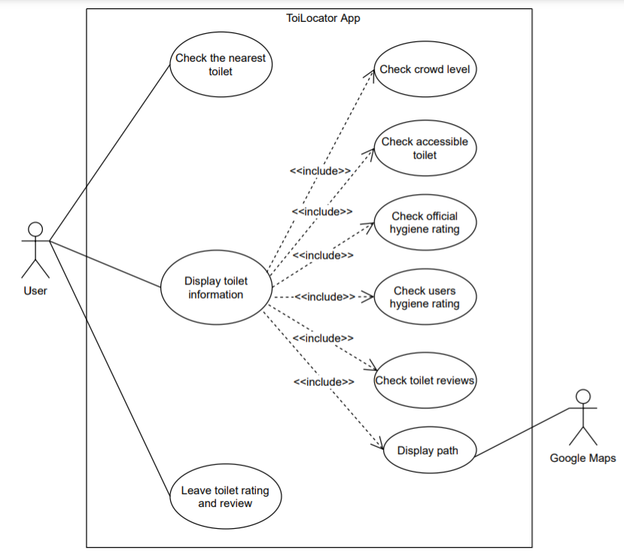

**Interface with other systems**

1. The system must be able to support finding the user’s current location using the phone’s built-in GPS system, upon user’s approval of a location request.
2. The system must be able to display map information using a selected map API, similar to how UWave displays the map.

**Non-Functional requirements**

**Usability**

1. The system shall support the English language.

**Reliability**

1. At the same user location, the results obtained from *Requirement #1* shall be consistent 9 out of 10 times.
2. At the same user location, the results obtained from *Requirement #2* shall be consistent 9 out of 10 times.

**Performance**

1. *Requirement #1* shall be performed within 5 seconds..
2. *Requirement #2* shall be performed within 5 seconds

**Supportability**

1. The database of toilet information must be synchronized with Google API with a frequency no less than every 24 hour

**Data Dictionary**

|  |  |
| --- | --- |
| Term | Definition |
| Potential Crowd Level | An estimation of the potential crowd level in the select toilet based on Google API |
| Accessible Toilet | Toilets for disabled persons |
| Official Hygiene Rating | Rating scores provided by publicly available data sources, namely Restroom Association Singapore. |
| User Hygiene Rating | Rating scores provided by users of this application. |
| Toilet Review | Comment lines left by the users, following their experiences with the toilets that they have used. One can also attach an image to the review. |
| Nearby toilet | All public toilets which are within a walkable distance |
| Walkable distance | Any distance within 500m proximity of the user’s given location |